

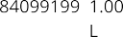
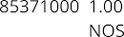
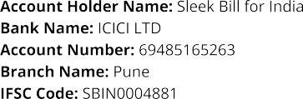
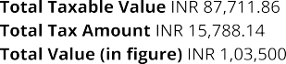
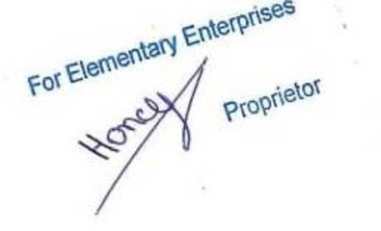

Gaba Industries
36, Kharadi, Hisar - 246423

039 45372027 mukti.tiwari@hotmail.com
XXXXXXXX 6EPKGM8186K0Z9
Vijayent Mutti

mktraders.com

GABA Industries

