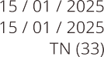

xxxxxxxxxx

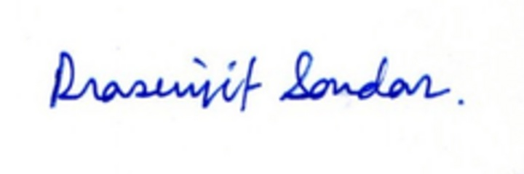







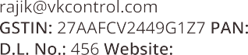

M K Traders

17, Radhe Villas, ZaraGarh Gurgaon - 201049

+19 41695014

[kumar.munaf@yahoo.com](mailto:kumar.munaf@yahoo.com)

6CHOBH2585W7Z1 xxxxxxxxxx

mktrader.in

Rahul Sharma





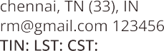

|  |  |  |  |  |  |
| --- | --- | --- | --- | --- | --- |
|  | | | | | |
|  |  |  |  |  |  |







MK Traders